New Honky Tonk Heroes Shirts!

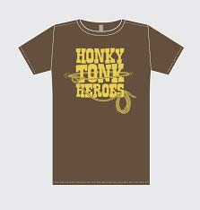

Available in Red and Brown

Men’s Med - XXL

Women’s Medium and Large